Name: Aaron Debbink | Contact Info: akdebbink@gmail.com | Date: 11/15/2018

Lesson Title : Modeling Non-Ideal Batteries, Testing and Construction | Unit #: 1 | Lesson #:  2 | Activity #:  3
Activity Title: Modeling Non-Ideal Batteries

Estimated Lesson Duration: | 10 days
Estimated Activity Duration: | 3 days

Setting: | Indian Hill High School, Room 118

Activity Objectives:

- The students will be able to make qualitative prediction about the effect on a circuit when the value of a resistor is changed in a part of that circuit.
- The students will be able to develop a procedure to experimentally determine the electromotive force (Emf) of a battery.
- The students will be able to develop a procedure to experimentally determine the internal resistance of a battery.

Activity Guiding Questions:

- What happens to the terminal voltage of battery under different resistive loads?
- How can we measure the electromotive force (Emf) of a battery?
- How can we measure the internal resistance of a battery?

Next Generation Science Standards (NGSS)
Science and Engineering Practices (Check all that apply) | Crosscutting Concepts (Check all that apply)
☐ Asking questions (for science) and defining problems (for engineering) | ☐ Patterns
☐ Developing and using models | ☐ Cause and effect
☐ Planning and carrying out investigations | ☐ Scale, proportion, and quantity
☐ Analyzing and interpreting data | ☐ Systems and system models
☐ Using mathematics and computational thinking | ☐ Energy and matter: Flows, cycles, and conservation
☐ Constructing explanations (for science) and designing solutions (for engineering) | ☐ Structure and function.
☐ Engaging in argument from evidence | ☐ Stability and change.
☐ Obtaining, evaluating, and communicating information

Ohio’s Learning Standards for Science (OLS)
Expectations for Learning - Cognitive Demands (Check all that apply)
☐ Designing Technological/Engineering Solutions Using Science concepts (T)
☐ Demonstrating Science Knowledge (D)
☐ Interpreting and Communicating Science Concepts (C)
☐ Recalling Accurate Science (R)

Ohio’s Learning Standards for Math (OLS) and/or
Common Core State Standards -- Mathematics (CCSS)
Standards for Mathematical Practice (Check all that apply)
☐ Make sense of problems and persevere in solving them | ☐ Use appropriate tools strategically
☐ Reason abstractly and quantitatively | ☐ Attend to precision
☐ Construct viable arguments and critique the reasoning of others | ☐ Look for and make use of structure
☐ Model with mathematics | ☐ Look for and express regularity in repeated reasoning

Unit Academic Standards (NGSS, OLS and/or CCSS):

- 4.E.5.2: The student is able to make and justify a qualitative prediction of the effect of a change in values or arrangements of one or two circuit elements on currents and potential differences in a circuit containing a small number of sources of emf, resistors, capacitors, and switches in series and/or parallel. [SP 6.1, 6.4]
- 4.E.5.3: The student is able to plan data collection strategies and perform data analysis to examine the values of currents and potential differences in an electric circuit that is modified by changing or rearranging circuit elements, including sources of emf, resistors, and capacitors. [SP 2.2, 4.2, 5.1]
- 5.B.9.7: The student is able to refine and analyze a scientific question for an experiment using Kirchhoff’s Loop rule for circuits that includes determination of internal resistance of the battery and analysis of a non-ohmic resistor. [SP 4.1, 4.2, 5.1, 5.3]
- 5.C.3.4: The student is able to predict or explain current values in series and parallel arrangements of resistors and other branching circuits using Kirchhoff’s junction rule and relate the rule to the law of charge conservation. [SP 6.4, 7.2]

Materials: (Link Handouts, Power Points, Resources, Websites, Supplies)

- Electric Multi-Meters
- Voltage Sensors
- Current Sensors
- Power Resistors
- Alligator Clips

Teacher Advance Preparation:

- There is NO advanced preparation for this activity.

Activity Procedures:

Day 1

- Ask the students what the function of a battery is in a circuit.
  - The students should identify that the battery provides a constant voltage difference across the connected circuit.
  - DEMO: measure the potential difference (voltage difference) across a battery (D cell) by itself vs. when in a circuit → Observation: the voltage difference drops when a there is current flowing through the battery and circuit. Also, the voltage difference drops by a larger amount when connected to an external circuit with lower resistance.
  - Ask the students the following questions to help them get to the idea that the battery must have some internal resistance if the terminal voltage drops when connected to an external circuit.
    - Why does the voltage across the battery terminals drop when connected in a circuit?
    - What is happening in the battery when connected to the external circuit? → current is flowing through it.
    - What type of circuit element has a voltage drop across it when current flows through it? → a resistor.

- Discuss how we can model a real world battery using an idea voltage source (Emf = electro-motive force) and an internal resistor in series. See the image below.

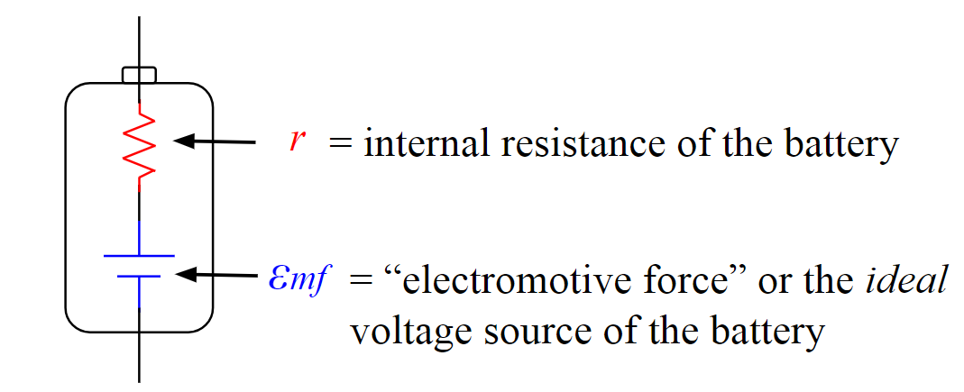

- Have student lab groups begin to use the following video to estimate the internal resistance of the battery and the Emf and document their data, analysis and any graphs on a large whiteboard to share with the class. Encourage advanced groups to find a way to graph their data and determine the Emf and internal resistance from a graph.
  - Video: Internal Resistance of a Battery Video

Day 2

- Have student groups finish using the following video to estimate the Emf and internal resistance of the battery and document their data, analysis and any graphs on a large whiteboard to share with the class.
  - Video: Internal Resistance of a Battery Video

- Handout a worksheet for individual students to work on once their lab group is finished with their whiteboard. This worksheet has the students solving complex circuit problems including one dealing with internal resistance.

- Once all student groups are finished finding the Emf and internal resistance of the battery, have the student groups present solutions and reach a general consensus about the internal resistance of a D cell battery → Is the internal resistance “ohmic”?

Day 3

- Check the homework for completion, and assign each student lab group one of the problems from assigned worksheet.
  - Each lab group should come to a consensus about their solution and record that solution on a large whiteboard. This should take between 10 and 15 minutes.
  - Have the student groups circle up and explain their solutions to their peers. Allow time for questions.

Formative Assessments: Link the items in the Activities that will be used as formative assessments.

This activity provides many opportunities for the teacher to formatively assess the students’ knowledge about the Emf and internal resistance of a battery. The teacher is able to walk around the classroom while students are using the video data to estimate the desired values. The students will also be verbally sharing their ideas with the class. This will provide additional opportunities for the teacher to formatively assess the students’ knowledge about the Emf and internal resistance of a battery.

Summative Assessments: These are optional; there may be summative assessments at the end of a set of Activities or only at the end of the entire Unit.

Content from this activity will be assessed on the post-test for the challenge based learning unit and the grading rubric for the design presentation. See the following documents.

- 1.0.0a Lithium Ion Batteries_Pre and Post Test_ADebbink
- 1.2.4f Lithium Ion Batteries_Presentation RUBRIC

Differentiation: Describe how you modified parts of the Lesson to support the needs of different learners.
Refer to Activity Template for details.

This activity gives different types of learners an opportunity to interact with the ideas in different ways. Hands-on learners will get to physically construct a circuit and physically take measurements on that circuit. Visual learners will be able to identify with the physical circuits during experimentation and the whiteboard illustrations of data collection and analysis for each group. Audible learners will benefit from the small and large group discussions with the circuit analysis. Regardless of learning style preference, all learners will benefit from having the information presented in various ways.

The nature of small group, collaborate work allows students who need more guidance to receive it. In small collaborate groups, the first place that students often receive help is from their peers. The teacher can also walk around listening to the student discussions and ask probing questions to help guide students toward a correct understanding. This allows the teacher to see where students are struggling and need extra guidance or help.

With this activity, the more advanced groups will be strongly encouraged to find the more difficult graphical solution to determine the Emf and the internal resistance of the battery.

Reflection: Reflect upon the successes and shortcomings of the lesson.

Instead of having the students find the internal resistance of a common D-cell battery, I decided to just give the students their lithium-ion cells for the project so they could experimentally determine the internal resistance for one of their battery cells. I thought it would save some time having them start working with their battery cells earlier in the unit, and it would give them more hands-on circuits experience since the alternative was having them “collect” data from a video I previously made. When I shared the two options, the students communicated that they were more interested in testing their lithium-ion cells than doing it for a different kind of battery from a video.

